Color Blender

1. Extract Color Blender Activity v1.1 folder to desktop
2. Open Arduino-1.0.5–r2 -> arduino.exe
3. In the Arduino IDE toolbar, select File -> Open -> Desktop -> Color Blender Activity v1.1 -> makey_makey_1_4_1 -> makey_makey_1_4_1.ino
4. Arduino will open a new Arduino window with two tabs called makey_makey_1_4_1 and settings.h
5. Plug in the MaKey MaKey
6. Open device manager (You can search for it by clicking the Windows Start button)
7. Under ‘Other Devices’ Arduino Leonardo will appear.
8. Right click it -> update drivers -> click Browse -> Color Blender Activity v1.1 -> Arduino-1.0.5 – r2 -> drivers -> click open -> click install
9. Go back to the Arduino IDE toolbar, select Tools -> Board -> Arduino Leonardo

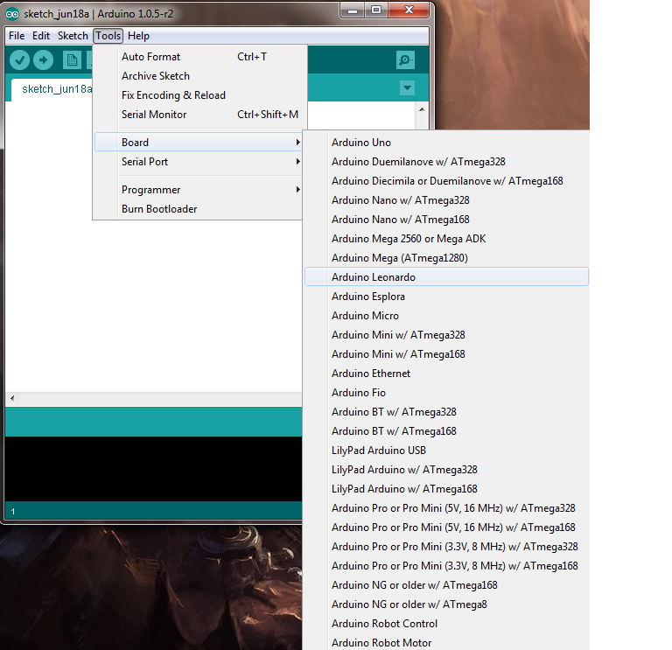

1. Then select Tools -> Serial Port -> (Click the COM port that corresponds with the port number beside Arduino Leonardo in device manager.)
2. Click the upload button in Arduino and immediately go back to device manager and watch for MaKey MaKey to appear under the ‘Ports’ section.
3. When it appears right click it as fast as possible and select properties (Note: if you don’t right click quickly enough you will need to unplug the MaKey MaKey)
4. Switch to Driver tab. Select Update Driver -> Browse my computer for driver software -> click Browse -> Color Blender Activity v1.1 -> driver. Then click Next
5. Now go back into Arduino and change the serial port (Under Tools) to match the new COM port number under ‘Ports’ in Device Manager.
6. Click the upload button in the Arduino IDE. (You should wait for the upload to complete. There may be upload errors, if so attempt next step) The MaKey Makey setup should now be complete.
7. Double click the Color Blender.jar file in Color Blender v1.1 folder which should be on the desktop. This will run the Color Blender program.

Controlling Color Blender

Each color has a value 0-255 and can be increased by increments of 15

1. Left Arrow Key increases the red value.
2. Up Arrow Key increases the blue value.
3. Right Arrow Key increases the green value.
4. Space button decrements the values in the order they were incremented.
5. Click button sets the values back to 0 and sets the color back to black.